Homework Problem Set 7: Database Programming

# Overview

In this lab, we will explore database programming of procedures, views, triggers, and functions.

## Learning Objectives

Upon completion of the lab, you should be able to:

* Write your own data logic as user-defined functions.
* Write your own data logic as triggers.
* Write your own data logic as stored procedures.
* Use built-in functions to solve data-logic-type problems.

## What You Will Need

To complete this lab, you will need the learn-databases environment up and running, specifically:

* Microsoft SQL Server DBMS.
* Provision the **TinyU** database using the database provisioner application <https://localhost:5000>.
* Azure Data Studio connected to SQL Server with an open query window.
* Please review the first lab if you require assistance with these tools.

# Questions

Answer these questions using the problem set submission tem For any screen shots provided, please follow the guidelines for submitting a screen shot.

Write the following as SQL programs. For each, include the SQL as a screen shot with the output of the query.

1. In the **TinyU** database:
   1. Write an SQL Stored procedure called **p_upsert_major**, which, given a major_code (business key) and a major_name, does an Upsert, which is the following:
      1. Checks if the major_code exists in the table already.
      2. If yes, updates the table and makes the major_name match the new major name.
      3. If no, inserts the new major_name and major_code into the table. HINT: major_id is not a surrogate key, so you will need to determine the next ID yourself in code!
   2. Test your stored procedure by executing it to make these changes:
      1. Change : CSC—Computer Sciences to CSC—Computer Science
      2. Add: FIN—Finance

Make sure your screen shot captures all up/down code in 1.a AND another screen shot captures 1.b—the output of your code execution—to show that it works. SELECT the table before and after!

1. In the **TinyU** database:
   1. Write a user-defined function called **f_concat** that combines the any two varchars @a and @b together with a one-character @sep in between.   
      For example:  
      
   2. Now create a view called **v_students** that displays the student_id, student name (first last), student name (last, first), GPA, and name of major. You should call the function you created in 2.a. After you create the view, execute it with a SELECT statement.

Make sure your screen shot captures all up/down code in 2.a AND another screen shot captures 2.b, along with the output of the SELECT statement on the view (first few rows is fine).

1. In the **TinyU** database:
   1. Write a query on the **majors** table so that the major_name is broken up into keywords, one per row. HINT: You must use string_split() with cross-apply.   
      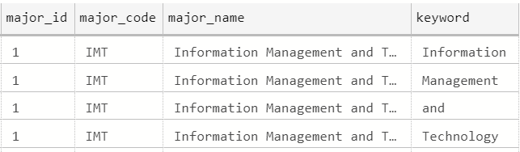
   2. Then use the query in 3.a to create a table-valued function **f_search_majors** that allows you to search the majors by keyword. Demonstrate calling the TVF by querying all majors with the “Science” keyword.

Your screen shot should include the query in 3.a Another screen shot should show the TVF in 3.b and the sample output from the SELECT statement calling the TVF.

1. In the **TinyU** database:
   1. Alter the **students** table and add the following columns:
      1. student_active char(1) default (‘Y’) not null
      2. student_inactive_date date null
   2. Create a trigger on the **students** table: when there is an student_inactive_date set, set student_active to ‘N’, and whenever there is not a student_inactive_date, then student_active is set to ‘Y’.
   3. Write SQL code to deactivate all the ‘Graduate’ students with a date of ‘2020-08-01’.
   4. Write SQL code to reactivate all the ‘Graduate’ students.

Provide a screen shot of your code from 4.a. and 4.b working. Provide another screen shot demonstrating 4.c worked. Then, provide a final screen shot of code and demonstration of 4.d working.